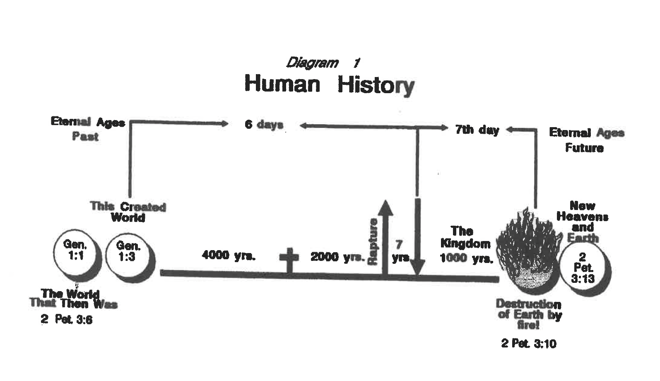

Scripture -Human History on the Earth - 1995 New American Standard Version – Dr Mark Miller 8-17-2025

- Colossians 1:25-29
²⁵ Of this church I ^{[a]}was made a minister according to the stewardship from God bestowed on me for your benefit, so that I might ^{[b]}fully carry out the preaching of the word of God, ²⁶ that is, the mystery which has been hidden from the past ages and generations, but has now been manifested to His ^{[c]}saints, ²⁷ to whom God willed to make known what is the riches of the glory of this mystery among the Gentiles, which is Christ in you, the hope of glory. ²⁸ We proclaim Him, admonishing every man and teaching every man ^{[d]}with all wisdom, so that we may present every man ^{[e]}complete in Christ. ²⁹ For this purpose also I labor, striving according to His ^{[f]}power, which ^{[g]}mightily works within me.

- Genesis 1:1-2
1 In the beginning God created the heavens and the earth.² The earth was ^{[a]}formless and void, and darkness was over the ^{[b]}surface of the deep, and the Spirit of God was ^{[c]}moving over the ^{[d]}surface of the waters.
- Jeremiah 4:23-26
²³I looked on the earth, and behold, it was ^{[a]} formless and void;
And to the heavens, and they had no light.
²⁴ I looked on the mountains, and behold, they were quaking,
And all the hills ^{[b]}moved to and fro.
²⁵ I looked, and behold, there was no man,
And all the birds of the heavens had fled.
²⁶ I looked, and behold, ^{[c]}the fruitful land was a wilderness,
And all its cities were pulled down
Before the Lord, before His fierce anger.

- 2 Peter 3: 5-9; 10-13

⁵ For ^{[a]}when they maintain this, it escapes their notice that by the word of God the heavens existed long ago and the earth was formed out of water and by water, ⁶ through which the world at that time was destroyed, being flooded with water. ⁷ But by His word the present heavens and earth are being reserved for fire, kept for the day of judgment and destruction of ungodly men.
⁸ But do not let this one fact escape your notice, beloved, that with the Lord one day is like a thousand years, and a thousand years like one day. ⁹ The Lord is not slow about His promise, as some count slowness, but is patient toward you, not wishing for any to perish but for all to come to repentance.

A New Heaven and Earth

¹⁰ But the day of the Lord will come like a thief, in which the heavens will pass away with a roar and the elements will be destroyed with intense heat, and the earth and ^{[b]}its works will be ^{[c]}burned up.
¹¹ Since all these things are to be destroyed in this way, what sort of people ought you to be in holy conduct and godliness, ¹² looking for and hastening the coming of the day of God, because of which the heavens will be destroyed by burning, and the elements will melt with intense heat! ¹³ But according to His promise we are looking for new heavens and a new earth, in which righteousness dwells
- Joel 2: 2-3
² A day of darkness and gloom, A day of clouds and thick darkness.
As the dawn is spread over the mountains,
So there is a great and mighty people; There has never been anything like it,
Nor will there be again after it, To the years of many generations.
³ A fire consumes before them, and behind them a flame burns.
The land is like the Garden of Eden before them
But a desolate wilderness behind them, and nothing at all escapes them

- Matthew 25: 40-45
⁴⁰ The King will answer and say to them, ‘Truly I say to you, to the extent that you did it to one of these brothers of Mine, even the least of them, you did it to Me.’
⁴¹ “Then He will also say to those on His left, ‘Depart from Me, accursed ones, into the eternal fire which has been prepared for the devil and his angels; ⁴² for I was hungry, and you gave Me nothing to eat; I was thirsty, and you gave Me nothing to drink; ⁴³ I was a stranger, and you did not invite Me in; naked, and you did not clothe Me; sick, and in prison, and you did not visit Me.’ ⁴⁴ Then they themselves also will answer, ‘Lord, when did we see You hungry, or thirsty, or a stranger, or naked, or sick, or in prison, and did not ^{[a]}take care of You?’ ⁴⁵ Then He will answer them, ‘Truly I say to you, to the extent that you did not do it to one of the least of these, you did not do it to Me.’

- Revelation 20: 7-10; 11-14

Satan Freed, Doomed
⁷ When the thousand years are completed, Satan will be released from his prison, ⁸ and will come out to deceive the nations which are in the four corners of the earth, Gog and Magog, to gather them together for the war; the number of them is like the sand of the ^{[a]}seashore. ⁹ And they came up on the ^{[b]}broad plain of the earth and surrounded the camp of the ^{[c]}saints and the beloved city, and fire came down from heaven and devoured them. ¹⁰ And the devil who deceived them was thrown into the lake of fire and ^{[d]}brimstone, where the beast and the false prophet are also; and they will be tormented day and night forever and ever.

Judgment at the Throne of God
¹¹ Then I saw a great white throne and Him who sat upon it, from whose ^{[e]}presence earth and heaven fled away, and no place was found for them. ¹² And I saw the dead, the great and the small, standing before the throne, and ^{[f]}books were opened; and another ^{[g]}book was opened, which is the book of life; and the dead were judged from the things which were written in the ^{[h]}books, according to their deeds. ¹³ And the sea gave up the dead which were in it, and death and Hades gave up the dead which were in them; and they were judged, every one of them according to their deeds. ¹⁴ Then death and Hades were thrown into the lake of fire. This is the second death, the lake of fire.

- 2 Corinthians 5:10
¹⁰ For we must all appear before the judgment seat of Christ, so that each one may be recompensed for ^{[a]}his deeds in the body, according to what he has done, whether good or bad.

